**Assignment 3**

**Task:** Create a virtual Machine using the azure portal, install a web server and host a simple webpage.

**Task:** Manage the Created virtual machine, demonstrating how to start, stop and resize the vm.

* The simplest way to log in to Azure is to use the AZ login command.

* Creating a resource group with location as south India

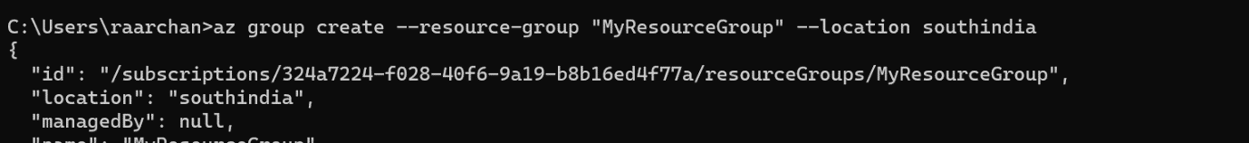

* Creating a virtual machine and access the command line of VM that is created.

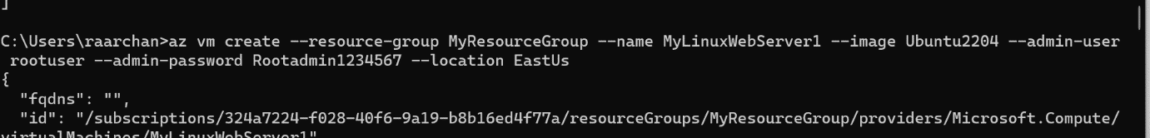



* Install nginx.



* Update the software so that the latest package is installed in future.



* Verify the default html page is working.



* Add inbound security rule to the MyLinuxServerNSG having priority of 300.

* Give access to read, write and execute to the files to html and CSS files in the VM.

Creating a html, CSS project on your local machine that need to be hosted on the newly created VM.

